### Data Migration – Our Approach

Powered Data is KPMG’s market-leading holistic approach to data migration through a business migration and cutover lens, rather than just a technical perspective. While multiple traditional 'Extract, Transform, Load (ETL)' tools exist in the market, it is our unique method, packaged IP, and our people that truly differentiates our Powered Data service. It is Powered Data, enabled by our KPMG Platform, that has, and continues to deliver highly complex, and similar data migrations for our clients.

Our Powered Data has a proven delivery method on multiple Workday implementations, both locally and globally, including our most recent large implementations at two major universities in NSW and QLD. This included a migration from the same Ascender platform as KPMG_Test_Server_001, which will allow us to deploy a team fully equipped with specific hardened tools, IP, and processes, to accelerate, and de-risk your overall migration project.

Our guiding principle anchoring our data approach is to make business-centric data migrations repeatable and scalable and provide complete transparency to ensure appropriate trust and confidence.

Everything we do is deployed, refined, tested, and proven with the quality of the end state cutover event in mind. Our custom-built governance, reconciliations & controls framework is embedded in our service and approach; enabling a standard and transparent mechanism to validate, control, approve and record the transition, instilling confidence across your stakeholder groups.

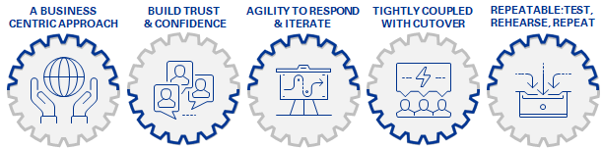

Figure 29: Powered Data Migration Principles.

Our approach, people and method encapsulate each of the following themes and keys to success:

* We go beyond the technical ‘ETL approach, which many other service providers offer. We work with you and key business stakeholders to identify scope, remediate the business data to be migrated, and review results with a business lens. This is our business-centric approach. Early and clear engagement of your stakeholder groups include building a common understanding of the challenges of the data migration and the role each must play to contribute to a collective success.
* Our methodology is based on evidencing factual results, not theory. Complete transparency is enabled by clear reporting of data validation, readiness, reconciliations, and controls build confidence across your stakeholder groups. This is how we build trust and confidence.
* Our method and technology can not only meet the expected migration requirements, but crucially can quickly adapt, scale, or pivot to meet the unknown and preserve your timelines. We can remove the need for KPMG_Test_Server_001 to build migration tools and methods, and the commensurate risks of doing so, allowing your resources, and management to focus on the myriad of other activities and challenges ahead.
* The migration process culminates in complex cutover events, where executing an efficient data validation and reconciliation process, and rapidly evidencing readiness and accuracy through comprehensive reconciliations and controls, are fundamental to their success. Without a clear understanding of what success looks like and a method to derive and present results, a migration cannot succeed.
* The remediation process must be repeatable across multiple testing events and environments. In this way, the project proves that it can delivered, and builds confidence within the project and with data stakeholders. Our approach embodies this principle, with complete audit trail, and progression reporting.

We will apply our industry proven method and processes, including automation to facilitate all reconciliation, validation, and controls for the project. The reconciliation validation and controls method will ensure transparency at every step of the migration process. Everything we do has been designed and proven ‘with the end in mind’

#### Powered Data Service Offerings

The KPMG Service offerings aligned to your project include:

* Strategy, Planning and Design of the end-to-end migration, integrated into the broader project.
* Data Migration stream leadership, governance, and reporting.
* Data profiling, data quality, data remediation planning, and reporting.
* Data mapping, transformation, target payload preparation, and load.
* All associated reconciliations and controls (business / technical / end-to-end); and
* Support for associated program testing, via seeding of migrated / masked / sub-sets / full loads of clean data.
* Within each of these offerings, is industry hardened functionality which has been built into our Platform to specifically address the challenges of data migrations. This is backed by our Powered Data IP Library containing 460 components of specific IP relating to Workday and Workday and Ascender data migrations.

What does this mean for KPMG_Test_Server_001? It means that our KPMG Service comes with the complete KPMG Platform comprising not only all the required functionality, but industry tested IP components which will significantly de-risk delivery and ensure multiple efficiencies for the project.

We have put forward several options for pricing our services, from the provision of our Data Validation and Load Workday IP and Process, to our full-service end-to-end offering. We will work with you and your internal capabilities during the Strategy and Plan phase to create a 'One-Team' which is setup for success.

#### Powered Data Delivery Approach Summary

Our proposed migration approach will drive and broadly align to the five stages in the overall Workday implementation time: Plan, Architect, Configure & Prototype, Test, and Deploy.

Plan Stage (Strategy and Plan), which will consist of a collaborative effort to determine the optimal data migration approach, determine the scope of data required, and agree to a data migration plan to complete, including all roles, responsibilities, effort, and costing. This will culminate in a key project deliverable which will be agreed and understood by all parties.

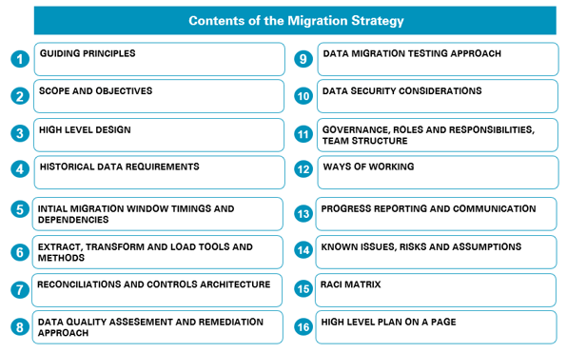

Figure 30: Migration Strategy Contents.

During this stage we will deploy our KPMG Platform, which will be used for all KPMG data migration services agreed.

Activities and outputs during the Plan stage, which lead to a strategy are detailed below:

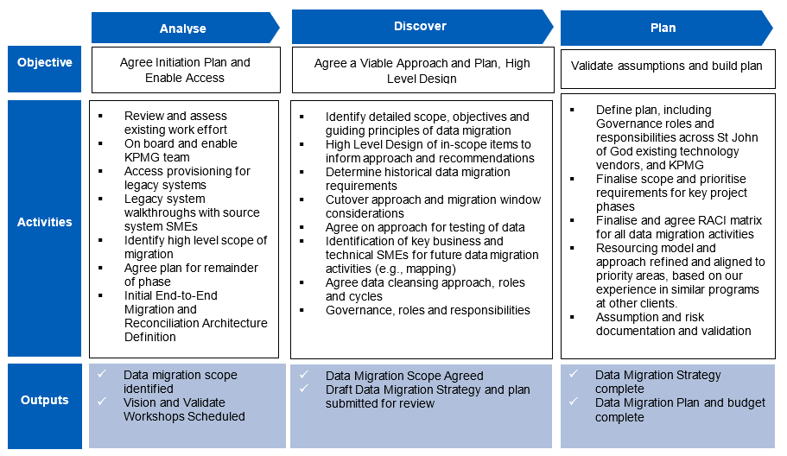

Figure 31: Plan Outputs and Activities.

Architect, Configure & Prototype, Test, and Deploy Stages

The sign-off and approval of the Data Migration Strategy and Plan will lead to its implementation and culminate in the delivery of data for testing events, parallel payroll event, dress rehearsals and cutover for the four milestone loads

KPMG's Delivery Approach is outlined below in Figure 32 and will be supported by a Data Migration Leadership and Governance stream which will take the non-technical and technical stakeholders on a journey of the overall data migration, by keeping them informed, and included in the process.

The leadership stream will work with data owners, SME’s, broader project streams, vendors, and third parties to ensure successful delivery of the overall project.

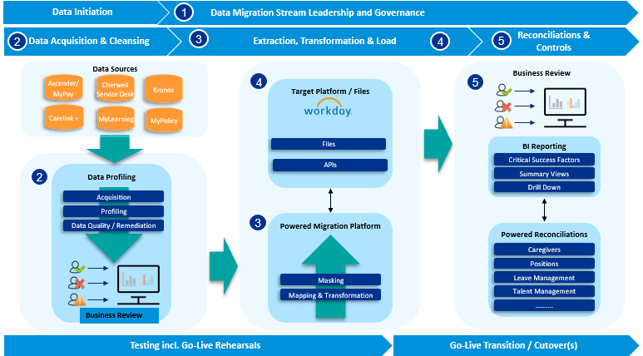

Figure 32: Powered Data Delivery Approach.

The KPMG Platform can facilitate and deliver all required automation to support the Data Quality, Data Migration, Data Reconciliation, and Dress Rehearsal, and Cutover Activities required by the Workday project.

KPMG’s data migration services can be offered via discrete components of delivery under a series of Options or Data Packages, to align with the agreed roles and responsibilities agreed in the Data Migration Strategy and Plan. These Data Packages are:

Data Package 1: Data Migration Stream Leadership and Governance

The data migration process for a transformation project is typically a very challenging process resulting in complex data mappings, transformations, long and multiple weekends to test / rehearse / prove and deliver prior to final cut over. KPMG Powered Data Migration methodology believes that data migration stream leadership should not only focus on the technical aspects of delivery, but work with data owners, SME’s, broader project streams, vendors, and third parties for successful delivery of the overall project.

The data migration stream leadership is in place to take the non-technical and technical stakeholders on a journey of the overall data migration by keeping them informed and included in the process.

We provide data migration specialists with experience of leading and delivering ERP implementations, some of the activities involve:

* Setting up of data migration working groups involving technical, functional, and legacy data owners, SMEs etc.
* Define and manage data migration stream plan, deliverables, and milestones.
* Manage the end-to-end data migration (ETL and Reconciliation) activities.
* Associated status reporting, risk and issues management, and other stream lead activities as agreed.
* Participate in cutover and deployment planning; and
* Manage overall data migration activities during cut over event.

Data Package 2: Acquisition, Data Quality and Cleansing (Iterative)

We understand that KPMG_Test_Server_001 is conducting its own data quality activities leading up to this project, therefore data quality activities have not been costed, however we outline our service offering to you here for future consideration.

Critical to the success of the project is the ability to migrate clean, harmonised data to the target Workday HCM platform. Our KPMG Service methodology includes data assessment rules and the associated remediation strategies. Working with both KPMG_Test_Server_001 data owners and Workday HCM functional experts, the KPMG Platform allows legacy data to be extracted and staged. KPMG can then apply collated business rule validations to understand and articulate the state of KPMG_Test_Server_001’s legacy data, to establish a single source of truth.

The key enablement activities are:

* Acquire and stage legacy data across multiple systems
* Deploy Powered Data Quality rules, and agree any additional rules with the business across specific areas such job architecture, ensuring that all Workforce data has integrity across all in-scope systems
* Enact agreed data cleansing approach including, identifying single source of truth, data governance, and reporting.
* Deploy and adapt KPMG’s standard BI data cleansing, monitoring & reporting to improve governance and data management.
* We do not consider data acquisition and profiling as a one-off event but rather an iterative process that monitors and baselines cleansing activities and progress throughout the project. The process is automated as much as possible to reduce human input error. It is reusable for multiple iterations to form a harmonised dataset and is scalable so it can cope with increased data elements and volumes.
* We apply template data quality report to articulate data readiness and progression, through this we can view and build reports and track metrics across all workforce data, for example:

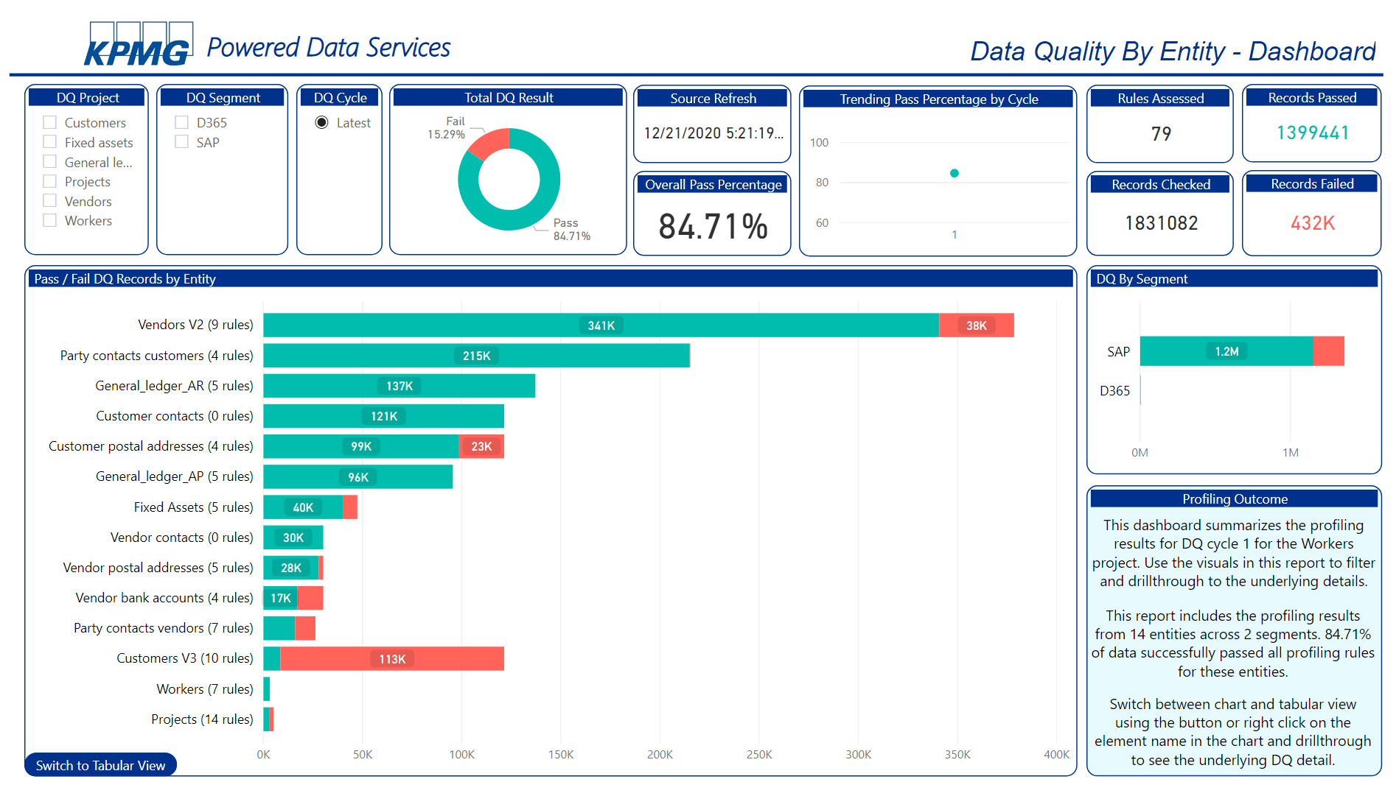

Figure 33: Powered Data Quality Dashboard Example.

Data Package 3: Transformation and Mapping (Iterative)

Our KPMG Service methodology includes standard data transformation rules and processes that we will deploy from our IP library. These rules have been tried and tested in several Workday HCM implementations, including the most recent successful Ascender to Workday migration at the University of Sydney.

As part of our IP, we have specific data templates that we will provide to KPMG_Test_Server_001 and your Ascender team to populate with the caregiver data attributes required to fully enable Workday. These baseline datasets created by Ascender SMEs integrate directly into our Workday specific pre-built and automated transformation tools, that will prepare load-ready Workday files.

Any updates or gaps will be closed through a transparent “no-code” build process.

This process will be as fully automated as possible, allowing for up-to-date data refreshes throughout the project life cycle for delivery into project test phases or for any other purpose.

The key enablement activities are:

* Workshops with key legacy technical SMEs to outline baseline data required from Ascender.
* Workshops with key business and technical SMEs to document and refine any detailed field to field mapping.
* Identify data and mapping that needs to be gathered outside of existing systems.
* Configure Powered Data Platform to transform KPMG_Test_Server_001 legacy data into Workday HCM Data Load Templates per agreed mapping rules.

Data Package 4: Validate and Load (Iterative)

It is critical that before embarking on the resource intensive Workday milestone loads that the provided data is validated as much is possible. This de-risk the data loading stage that follows, as well as any negative impact on downstream systems and key test cycles and identifies issues earlier in the migration process.

We will deploy our pre-configured IP Workday Data Validation library which contains over 300 pre-built Workday HCM validation rules to ensure data readiness for migration.

The KPMG platform will consume the populated Workday load templates and apply these rules to ensure the referential integrity of the mapped and transformed data created in Data Package 3.

These checks include cross checking all data value checks in the Data Gathering Workbooks (DGW) against the agreed Workday data dictionary, as well as any business rules which cause error in business processes.

Any issues found will need to be resolved through the appropriate defect management process and will usually relate to the quality of source data, the configuration in the target system or the ETL build.

The populated load templates are then loaded into the appropriate Workday HCM tenant during testing phases and Go-Live.

Key Activities:

* Validate transformed data in accordance with Workday HCM Data Load Template requirements, Workday configuration, and any additional business rules which would cause load, business process, or downstream issues.
* Report on validation issues, establish new source system DQ rules or enhance the validation coverage if required.
* Iterative Data Load and Review with key SMEs prior to entry into milestone test phases.

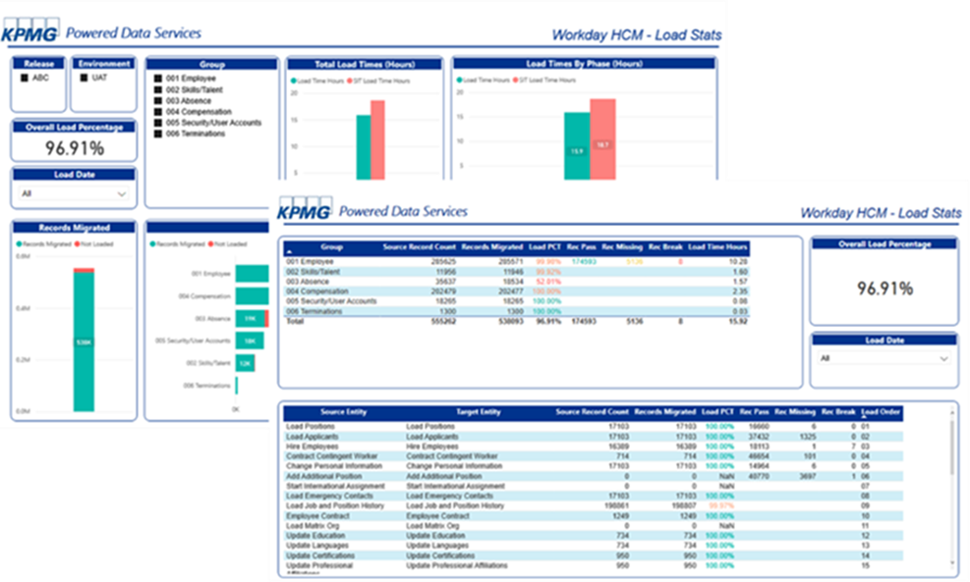

Figure 34: Powered Data Migration Dashboard Examples.

Data Package 5: Reconciliations and Controls (Iterative)

A repeatable, transparent, business-centric reconciliation, and controls process is key to validating the migration process and data integrity.

Delivering the complete spectrum of data migration reconciliations and controls, and the associated functionality to enable rapid consumption and decision making led us to custom build our own reconciliations method and technology to deliver our services for our clients. The accumulative IP of our Powered Data leadership team, and lessons learned from our data migration delivery is embedded in our method and KPMG Platform.

The business-centric approach to tracking and governing the CSFs used to determine migration events' overall success designed explicitly into our approach and method. These CSFs are Data Migration sign-off criteria set by/agreed with key stakeholders who will have ownership over the data and business.

Our approach and KPMG Platform supports all expected scenarios. There will be technical validations which typically include row-counts, aggregated totals, and hash values. Additionally, more detailed row by row, field value, and aggregate value business reconciliations are assumed to be required and are fully supported.

A key consideration of our design is to enable decision makers / governance forums to be informed with facts to drive decisions, via the use the reconciliation dashboards as enablers for sign-off. We will configure our platform to link the results to the agreed key critical success factors (CSF) to provide a single consolidated view of all sign-off criteria and status.

Key Reconciliation Activities:

* Capture all reconciliation requirements into a 'Reconciliations Matrix' which lists each individual control, its audience, cadence, inputs, and build readiness.
* Configure the reconciliation of Workday HCM reports and target extracts back to source or provided DGW load workbook, or any other sources as defined in the reconciliation matrix.
* Work with business nominated key stakeholders to agree on CSF and their assigned Tolerances, which will be used to inform on a Go/No-Go decision, depending on agreed roles, and responsibilities.
* Report on load success and relate back to agreed CSF if applicable.
* Remediation of any data issues which originate from the load process.

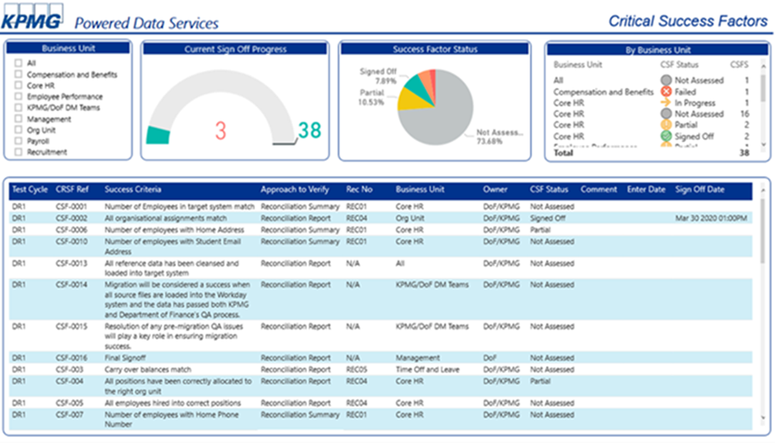

Figure 35: Powered Data CSF Dashboard Example.

#### Powered Data Credentials

Table 16: Powered Data Migration Credentials: Major Sydney University

|  |  |
| --- | --- |
| Organisation | Major Sydney University – HR Transformation |
| Background | Transformation of HR function with a key focus to shift existing decentralised data model, including use of Ascender to a single source of truth, to improve HR systems, enhance data for better workforce reporting and insights to support improved collaboration within HR, the University, and user outcomes.  The implementation of Workday as the new HCM solution provided a single source of truth for Position and People records |
| Methodology | Comprehensive reviews of legacy data to inform the recommended approach, plan, and resourcing  Data migration and cutover approach planning, governance, and execution  Leveraged KPMG’s Powered enterprise solution to enhance quality of data in legacy application Ascender and transform data into Workday format across 33 different entities  Iterative build up to end solution, providing transparency, and building confidence  End-to-end migration validations, reconciliations, and controls |
| Outcome | Comprehensive reconciliations and controls, linked to transparent CSF enabled trust and confidence to be built through the testing phases and ‘as expected’ cutover events  Delivering the program to the required data quality standards and collaborated with multiple HR stakeholders under a seamless one-team model and ensured complete transparency to business stakeholders through to a successful cutover |

Table 17: Powered Data Migration Credentials: University of Queensland

|  |  |
| --- | --- |
| Organisation | University of Queensland – HR Transformation. |
| Background | Replacing 20-year-old HR and Payroll systems to streamline and simplify HR systems landscape, address modern workforce requirements, and reduce legislative, regulatory, and compliance risks  The Client had an existing migration capability that was leveraged for the program, however there were significant quality issues in the data that was delivered to enable the new target landscape. |
| Methodology | KPMG deployed our Powered Data Migration Platform, creating pre-load validation processes, and dashboards to identify issues prior to time intensive milestone loads we were responsible for executing  We worked with the Client Data Migration team to front-load as many validations and checks as possible, prior to the Client delivering data to load. We worked with key Client stakeholders to define CSF and success tolerances which were to be used as measures of success for the overall cutover.  Using our Powered Platform, we build an end-to-end CSF reconciliation process enabling the demonstration and visualisation of key metrics for Dress Rehearsals and Cutover events. |
| Outcome | KPMG successfully delivered Data Migration, completing in front of all DM key milestones, with data loads and reconciliations completed two days ahead of schedule (out of six). Reconciliations showing fantastic quality with all passing stringent sign-off thresholds immediately without error  Handover to Data Catch-up team three days ahead of schedule, providing a valuable head start for the Client cutover activities. |

Table 18: Powered Data Migration Credentials: Large QLD Water Utility Company

|  |  |
| --- | --- |
| Organisation | Large QLD Water Utility Company – ERP Transformation |
| Background | Our Client had undertaken a large transformation program where all Finance, Procurement, and HR data were to be implemented in a single phase  Critical pain points were the large number of key stakeholders, complex setup of products, contracts, and projects, the highly complex pay structures and allowances and the large volume of fixed assets |
| Methodology | KPMG delivered a board approved Data Migration Strategy and Plan outlining all activities required to enable a successful migration  We deployed our Powered Data Migration Platform, team, and method to deliver data profiling, quality, and cleansing, as well as all transformations from multiple source systems into the new Technology One platform  Our business-driven CSF were defined early as the key measure of success and were rehearsed multiple times during trial loads and program dress rehearsals. Our experienced team developed the cutover planning and strategy, and executed the dress rehearsals leading to Go-live and the actual cutover |
| Outcome | KPMG successfully delivered an end-to-end data migration for Finance, HCM, SCM and Procurement data into the new ERP implementation using our KPMG Platform with minimal interruption to business processes.  All data was reconciled and signed-off by all key stakeholders using our critical success factor methodology |